**Setting Up Application Environment**

**Setup Mobile Application Environment**

|  |  |
| --- | --- |
| Date | 15 November 2022 |
| Team ID | PNT2022TMID11590 |
| Project Name | CONTAINMENT ZONE ALERTING |

**Create An Android Application :**

Open Android Application:

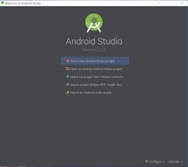

Start a New Android Studio Project :

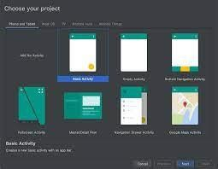

Select Basic Acitivity :

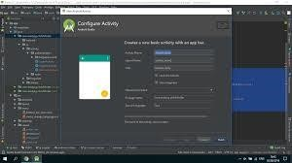

My Application Name My First App :

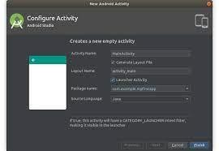

Language Set to JAVA :

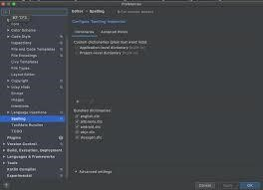

Leave the default for the other fields :

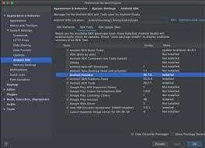

Click Finish :

